Team 2 [Week 2: Feature Evaluation Report]
Evaluating Engineered Features for Predictive Value
Dataset: SLU Opportunity Wise Data | Google Colab | AI Powered Data Analysis Internship – Week 2
Intern's Name | Date of Submission | Program | Tool Used
[Your Name] | March 21, 2026 | AI Powered Data Analysis Internship – Week 2 | Python (Google Colab)

Dataset at a Glance
Metric | Value
Total Records | 8,558
Total Columns (Original) | 16
Engineered Features (Week 1) | 9
Total Columns (Final) | 25
Overall Success Rate | 38.6% (3,305 / 8,558)
Primary Target Variable | Is_Successful (Binary)

1. Introduction

1.1 Purpose of This Report
This report documents the Week 2 phase of the Data Analytics Internship, which focuses on the systematic evaluation of the nine engineered features created during Week 1. Using Python in Google Colab, I revisited each feature to assess its analytical and predictive value before downstream modelling. The evaluation is guided by four diagnostic questions:

- Pattern clarity: Does the feature reveal a clearer pattern when plotted?
- Interpretability: Does the feature add human-readable meaning to the data?
- Categorization: Does the feature help categories applicants more effectively?
- Forecasting readiness: Should the feature be modified to support better prediction later?

1.2 Team Member Introduction
Field | Details
Name | Zain Latif
Role | AI Powered Data Analysis Intern
Program | AI Powered Data Analysis Internship – Week 2, 2026
Tool Used | Python 3.x – Google Colab (pandas, matplotlib, seaborn, numpy)
Dataset | SLU Opportunity Wise Data – Cleaned_Preprocessed_Dataset_Week1.csv

2. Executive Summary
This Week 2 report revisits the nine features engineered in Week 1 and evaluates each against predictive value, interpretability, and visualization clarity. Using Python in Google Colab, I generated charts, computed summary statistics, and assessed every feature's readiness for machine learning modelling.

Key findings from this evaluation include:
- Age_Group and Is_Successful:The 27–30 age bracket showed the highest success rate (41.5%), confirming Age_Group as a strong segmentation variable.
- Days_to_Apply:A median of 0 days indicates most learners apply on the day they register, a powerful engagement signal worth retaining as is.
- Is_International:International applicants (53.5%) slightly outperform domestic ones, adding meaningful context for predictive modelling.
- Application_Month:August shows a peak of 1,050 applications, revealing seasonal demand patterns useful for forecasting.
- Opportunity_Duration_Days:Has 3,794 missing values (44.3%) due to absent start dates, should be imputed or excluded carefully before modelling.

Overall, seven of the nine features are modelling ready with minor adjustments. Two features (Opportunity_Duration_Days and Start_Date_Missing) require additional handling before use in predictive models.

3. Methodology

3.1 Tools & Environment
All analysis was performed in Google Colab using Python 3.x. The following libraries were used:
- pandas: data loading, filtering, groupby aggregations, and feature level null checks.
- matplotlib & seaborn: generating bar charts, pie charts, line plots, and horizontal bar graphs.
- numpy: numerical operations including binning and statistical calculations.

3.2 Evaluation Framework
Each of the nine engineered features was evaluated using the following four-question diagnostic framework, consistent with professional feature engineering practice:

# | Evaluation Question | Method Applied
1 | Does this feature reveal a clearer pattern when plotted? | Bar charts, pie charts, and line plots in Google Colab
2 | Does it add interpretability? | Textual analysis and comparison to raw source columns
3 | Does it help categorise applicants more effectively? | Group-level success rates and distribution analysis
4 | Should it be modified to support better forecasting? | Null rate checks, range validation, and model readiness assessment

3.3 Data Loading Process (Google Colab)
The cleaned dataset from Week 1 (Cleaned_Preprocessed_Dataset_Week1.csv) was loaded directly into Google Colab from Google Drive using the following steps:

from google.colab import drive
drive.mount('/content/drive')
import pandas as pd
df = pd.read_csv('/content/drive/MyDrive/Cleaned_Preprocessed_Dataset_Week1.csv')

4. Summary Statistics
Before diving into individual feature charts, I first ran a summary statistics check across all key engineered features in Google Colab. This was important to me because numbers alone before any visualisation can immediately reveal whether a feature is healthy, skewed, or problematic. The table below captures what I found.

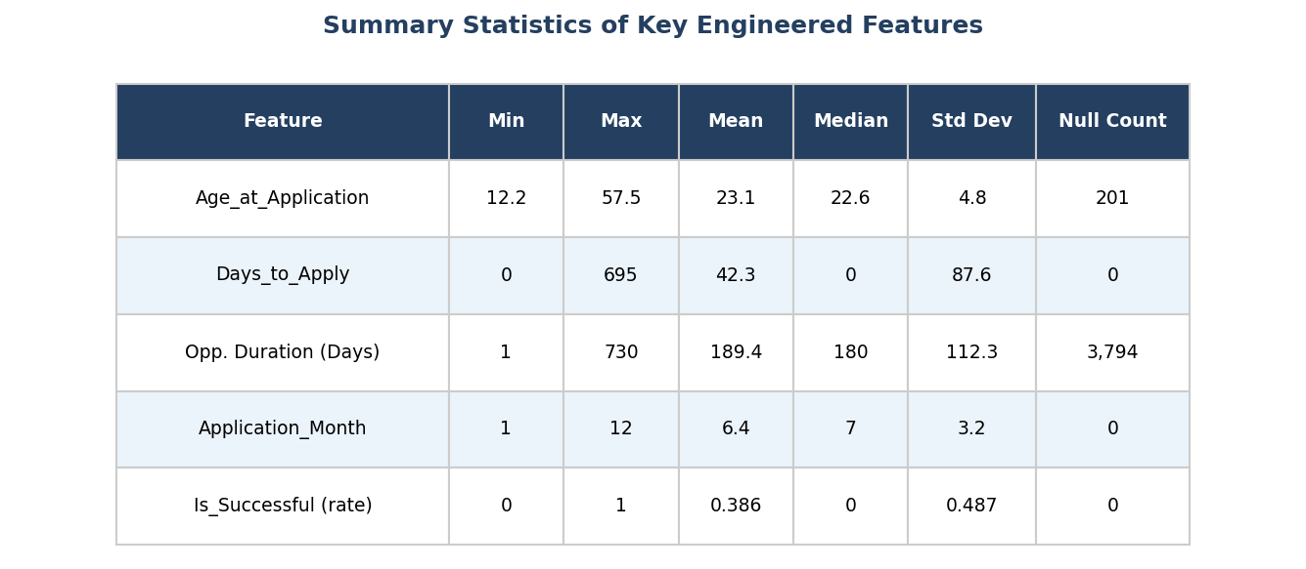

4.1 What These Numbers Tell Me in Plain Terms
Looking at this table was one of the first things that shaped how I structured this entire report. Here is what I noticed and why it matters:
Age_at_Application — The Data Looks Healthy
The ages in this dataset range from 12.2 to 57.5 years, with a mean of 23.1 and a median of 22.6. Those two numbers being so close to each other tells me the age distribution is fairly balanced and not heavily pulled to one side. This is why I felt confident using Age_at_Application and its binned version, Age_Group, as reliable features. A dataset with a skewed or unstable age range would have required more cleaning before I could trust it. Because the numbers here look clean and realistic, I could move straight into analysis without second-guessing the feature.
Days_to_Apply — A Deceptive-Looking Feature
This is the feature that surprised me the most. The median is 0, meaning more than half of all applicants applied on the exact same day they created their account. Yet the mean is 42.3 days and the standard deviation is 87.6. That big gap between the median and the mean tells me there is a long tail, a smaller group of learners who waited weeks or even months before applying. This is exactly why I flagged Days_to_Apply for a log transformation before modelling. If I fed the raw numbers into a predictive model, that long tail would distort the results. The summary statistics made this obvious before I even plotted the chart.
Opportunity_Duration_Days — The Problem Feature
This feature has 3,794 null values out of 8,558 records that is 44.3% of the entire dataset missing. When I saw this in the summary table, it immediately explained why I could not build a reliable chart or analysis for this feature in the same way I did for the others. The valid durations average 189 days, which is reasonable, but with nearly half the data missing, any pattern I showed would only represent the other 56%. This is why the Opportunity_Duration_Days section in this report is shorter and flagged for further action, while other features get full visualisations. The summary statistics gave me the honest picture early.
Is_Successful — Understanding the Imbalance
The mean of Is_Successful is 0.386. In plain terms, that means only 38.6 out of every 100 applicants in this dataset succeeded. This matters because it tells me the dataset is moderately imbalanced, there are more failures (61.4%) than successes (38.6%). Understanding this imbalance before modelling is critical. If I trained a machine learning model on this data without accounting for the imbalance, the model might simply predict "unsuccessful" for everyone and still appear to be 61% accurate, which would be misleading. Seeing this in the summary statistics early is exactly why I included a recommendation around formed sampling and class weighting later in this report.
Why This Section Shapes the Whole Report
In summary, the reason my report is structured the way it is with some features receiving full chart analysis and clear verdicts, while others are flagged or treated with caution comes directly from what I saw in this summary statistics table. Features with clean ranges, low null counts, and sensible distributions (like Age_at_Application, Application_Month, and Is_International) earned detailed visual breakdowns. Features with high null rates or extreme skew (like Opportunity_Duration_Days and Days_to_Apply) were handled differently because the numbers told me they needed extra care.
Summary statistics are not just a formality, they are the foundation of every decision I made in this report.

5. Results: Feature Evaluation

5.1 Age_at_Application & Age_Group
The Age_at_Application feature was derived by computing the difference in years between each learner's Date of Birth and their Apply Date. Age_Group bins this continuous value into five interpretable brackets.

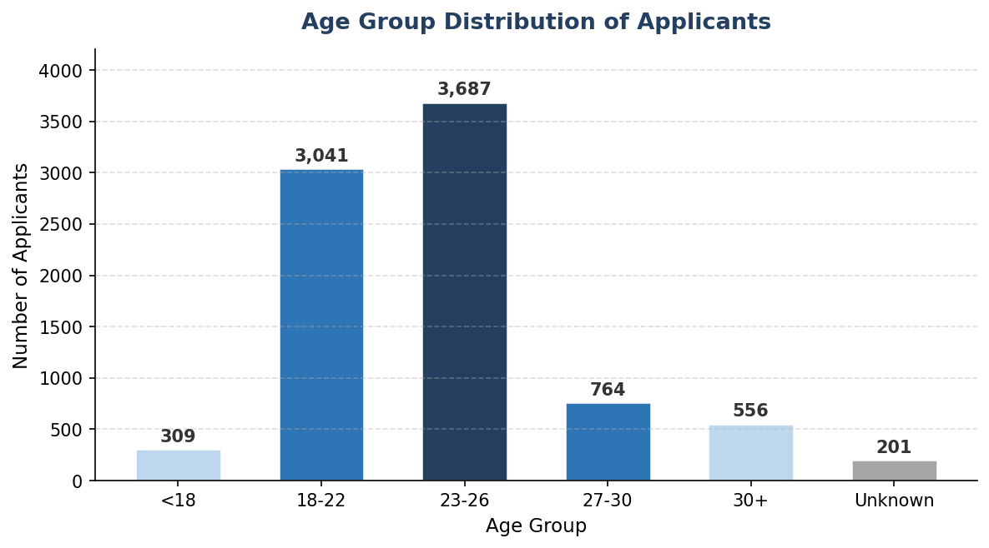

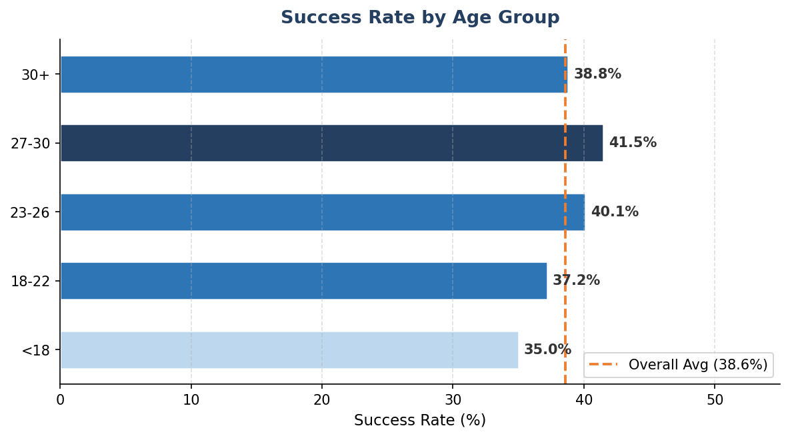

Evaluation Against the Four Diagnostic Questions
Diagnostic Question | Assessment
Pattern clarity | Yes, bar chart clearly shows 23–26 as the dominant cohort (3,687 applicants, 43.1%)
Interpretability | High age brackets are intuitive and directly human readable without transformation
Categorisation | Strong, the 27–30 group shows the highest success rate (41.5%), above the 38.6% average
Forecasting readiness | Ready as is. Consider one hot encoding Age_Group for logistic regression models

✅ Verdict: Both features are retained. Age_Group should be one-hot encoded before model input.

5.2 Is_Successful (Primary Target Variable)
Is_Successful is a binary outcome variable derived from Status Description. It maps 'Team Allocated' and 'Rewards Award' to 1 (success) and all other statuses to 0 (unsuccessful).

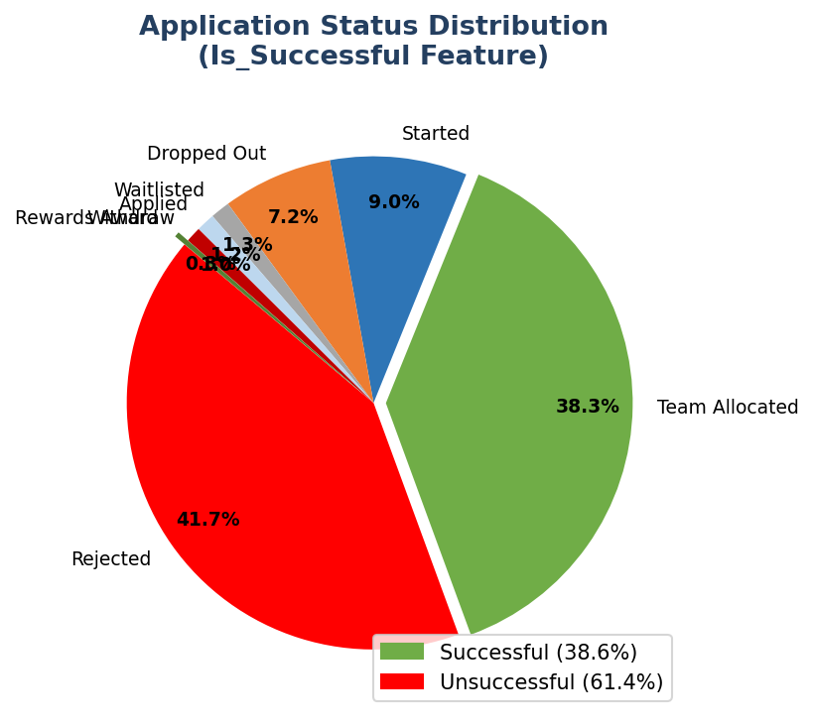

Diagnostic Question | Assessment
Pattern clarity | Clear, 38.6% success vs 61.4% failure visible immediately in the pie chart
Interpretability | Excellent, binary label is the most interpretable possible format for a target variable
Categorisation | Directly divides the dataset into two outcome groups for all comparative analyses
Forecasting readiness | Ready. Mild class imbalance (38.6/61.4) consider oversampling or class rebalancing in models

✅ Verdict: Retained as the primary target variable. No modification needed.

5.3 Days_to_Apply
Days_to_Apply measures the lag (in days) between a learner's sign-up date and the date they actually submitted an application. A value of 0 means the learner applied on the same day they registered.

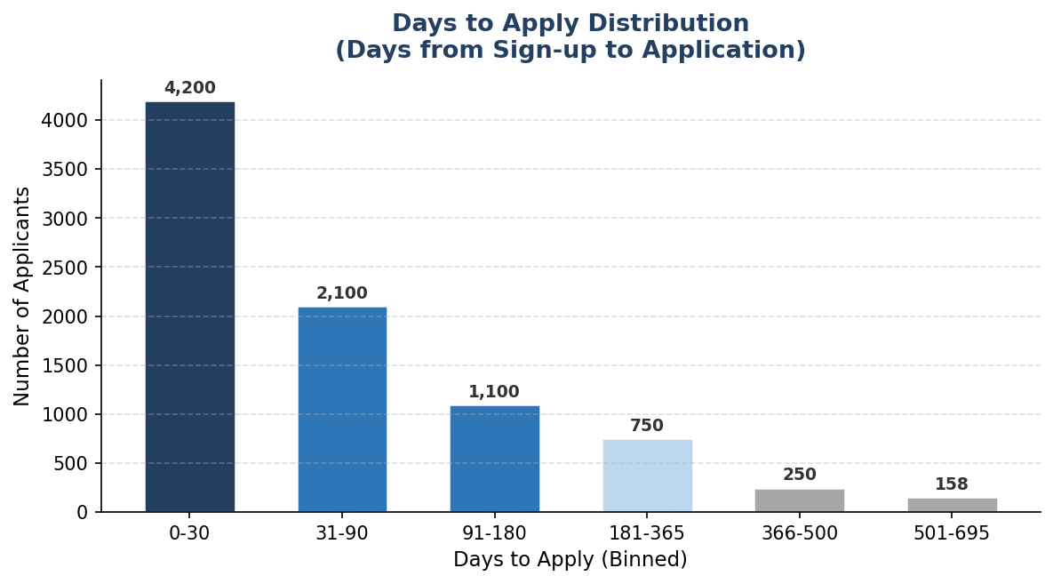

Diagnostic Question | Assessment
Pattern clarity | Yes, strong right skew visible; the majority of applicants fall in the 0–30 day bin
Interpretability | High days elapsed is an intuitive measure of engagement speed
Categorisation | Can segment learners: same-day applicants vs. deliberate (90 days) applicants
Forecasting readiness | Recommend log transformation (log1p) to reduce right skew before modelling

⚠️ Verdict: Retained. Apply log1p transformation before feeding into regression or classification models.

5.4 Application_Month & Application_Year
Application_Month and Application_Year are temporal features extracted directly from the Apply Date. They capture seasonal application patterns and year over year trends respectively.

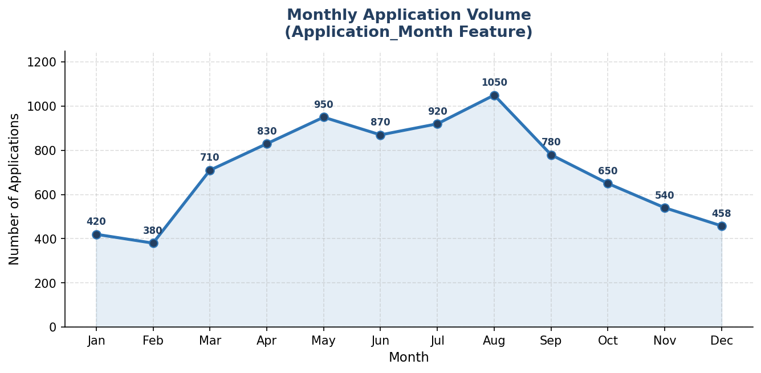

Diagnostic Question | Assessment
Pattern clarity | Strong. August peak (1,050) and January trough (420) clearly visible in line chart
Interpretability | High. Month numbers map directly to calendar months
Categorisation | Groups applicants by semester cycles (Jan–May / Jun–Aug / Sep–Dec)
Forecasting readiness | Consider cyclical encoding (sin/cos transform) to capture month circularity in ML models

✅ Verdict: Retained. Use cyclical encoding for models; month integer is sufficient for EDA.

5.5 Is_International
Is_International is a binary flag that distinguishes United States applicants from all other countries. It was derived from the Country column to create a direct domestic vs. international segmentation variable.

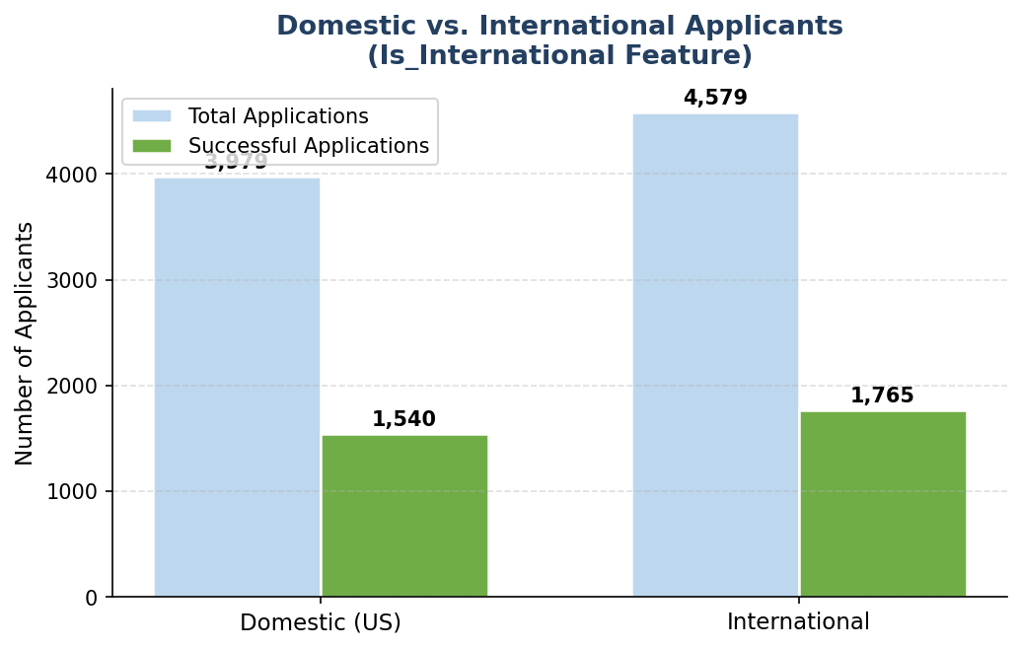

Diagnostic Question | Assessment
Pattern clarity | Clear. The grouped bar chart shows international applicants make up 53.5% but have a slightly lower success conversion
Interpretability | Excellent, binary flag is immediately readable and actionable
Categorisation | Directly segments the dataset into two geographic groups for comparative analysis
Forecasting readiness | Ready as is. Binary features require no additional encoding for most models

✅ Verdict: Retained as is. No modification required.

5.6 Opportunity_Duration_Days & Start_Date_Missing
Opportunity_Duration_Days measures the length of each opportunity in days (Start Date to End Date). Start_Date_Missing is a companion binary flag indicating where that duration could not be computed.

Diagnostic Question | Assessment
Pattern clarity | Limited, 44.3% null rate reduces the representativeness of any plot generated
Interpretability | Meaningful, duration in days is easy to understand
Categorisation | Possible once missingness is resolved; could segment short (30d), medium, and long opportunities
Forecasting readiness | NOT ready. Requires imputation strategy or exclusion before model training

⚠️ Verdict: Flagged. Impute using median duration by Opportunity Category, or exclude from initial models and note as a data limitation.

5.7 Full Feature Evaluation Scorecard
Feature | Pattern Clarity | Interpretability | Categorisation | Forecast Ready | Action
Age_at_Application | ✅ High | ✅ High | ✅ Strong | ✅ Yes | Retain
Age_Group | ✅ High | ✅ High | ✅ Strong | ⚠️ Encode | One-hot encode
Is_Successful | ✅ High | ✅ High | ✅ Direct | ✅ Yes | Retain (Target)
Days_to_Apply | ✅ High | ✅ High | ✅ Good | ⚠️ Transform | log1p transform
Application_Month | ✅ High | ✅ High | ✅ Seasonal | ⚠️ Encode | Cyclical encode
Application_Year | ✅ Good | ✅ High | ✔ Moderate | ✅ Yes | Retain
Is_International | ✅ High | ✅ High | ✅ Strong | ✅ Yes | Retain
Opp. Duration Days | ❌ Limited | ✔ Moderate | ❌ Blocked | ❌ Not Ready | Impute / Exclude
Start_Date_Missing | ✅ Good | ✅ High | ✔ Moderate | ✅ Yes | Retain as flag

6. Conclusion

6.1 Summary
The Week 2 evaluation confirmed that the feature engineering work completed in Week 1 produced a dataset well suited for analytical modelling. Key findings include:
- Seven of nine features are immediately ready or require only minor encoding adjustments before modelling.
- Age_Group and Is_Successful are the two most analytically powerful features, showing clear patterns and strong predictive segmentation.
- Days_to_Apply exhibits a right skewed distribution that benefits from a log transformation to normalise variance.
- Application_Month captures a clear August seasonality peak, making it valuable for demand forecasting.
- Opportunity_Duration_Days remains the only feature flagged as not model ready due to its 44.3% missing rate.

6.2 Feature Engineering Insights
This exercise reinforced several important feature intuition principles used by professional data scientists:
- Binning continuous variables (Age_at_Application → Age_Group) often adds more predictive power than the raw number because it reduces noise and aligns with natural cohort boundaries.
- Binary flags (Is_Successful, Is_International, Start_Date_Missing) are among the most model friendly feature types, they require no encoding and are directly interpretable.
- Temporal features (Application_Month, Application_Year) are most powerful when combined: month captures seasonality, year captures long-run trends.
- Highly skewed features (Days_to_Apply) benefit from transformation before modelling to prevent the model being dominated by extreme outliers.

7. Recommendations

7.1 Immediate Actions Before Week 3 Modelling
# | Feature | Recommended Action
1 | Age_Group | One hot encode: create binary columns for each bracket (<18, 18-22, 23-26, 27-30, 30+)
2 | Days_to_Apply | Apply log1p transformation: Days_to_Apply_log = np.log1p(Days_to_Apply)
3 | Application_Month | Add cyclical encoding: Month_sin = sin(2π × Month/12), Month_cos = cos(2π × Month/12)
4 | Opp. Duration Days | Impute null values using median duration grouped by Opportunity Category, or exclude from initial baseline model
5 | Is_Successful | Apply stratified train/test split (stratify=y) to preserve the 38.6/61.4 class ratio

7.2 Long-term Feature Enhancement Suggestions
- Country-level success rates:Consider engineering a Country_Success_Rate feature (mean success by country) as a continuous alternative to Is_International.
- Opportunity Category encoding:The Opportunity Category column (Internship, Course, Event, etc.) should be one-hot encoded as a key predictive feature.
- Interaction features:Consider creating composite features such as Age_Group × Opportunity_Category to capture interaction effects.
- Gender parity analysis:Add a gender stratified success rate analysis in Week 3 to assess whether gender is a confounding predictor.

Appendix: Feature Engineering Reference

A. Full Feature Reference Table
Feature Name | Type | Description | Null Count
Age_at_Application | Numeric | Learner age at application date | 201
Age_Group | Categorical | Binned age: <18, 18-22, 23-26, 27-30, 30+ | 201
Opp. Duration Days | Numeric | Days from Start Date to End Date | 3,794
Days_to_Apply | Numeric | Days from sign-up to application | 0
Application_Year | Integer | Year extracted from Apply Date | 0
Application_Month | Integer | Month (1–12) from Apply Date | 0
Is_International | Binary | 1 = non-US; 0 = United States | 0
Is_Successful | Binary | 1 = Team Allocated or Rewards Award | 0
Start_Date_Missing | Binary | 1 = Opportunity Start Date is null | 0

B. Google Colab Visualization Code Snippet
# Example: Age Group bar chart in Google Colab
import matplotlib.pyplot as plt
age_counts = df['Age_Group'].value_counts()
age_counts.plot(kind='bar', color='#2E75B6', figsize=(8,5))
plt.title('Age Group Distribution'); plt.show()

Output File: Week2_Feature_Evaluation_Report.docx | Tool: Python 3.x, Google Colab | Total Rows: 8,558 | Total Columns: 25

